FirstTerm

[Final Project 2]



Mastering Embedded System Online Diploma

<www.learn-in-depth.com> [By Eng.K.S.]

Eng. Mohamed Abd El Hakeem El Said Ali.

My Profile: [eng.mohamedhakim2122000@gmail.com (learn-in-depth-store.com)](https://www.learn-in-depth-store.com/certificate/eng.mohamedhakim2122000%40gmail.com)

Student Information Management System

# Add Manually:

# Add with Previous Roll:

# Add Manually:

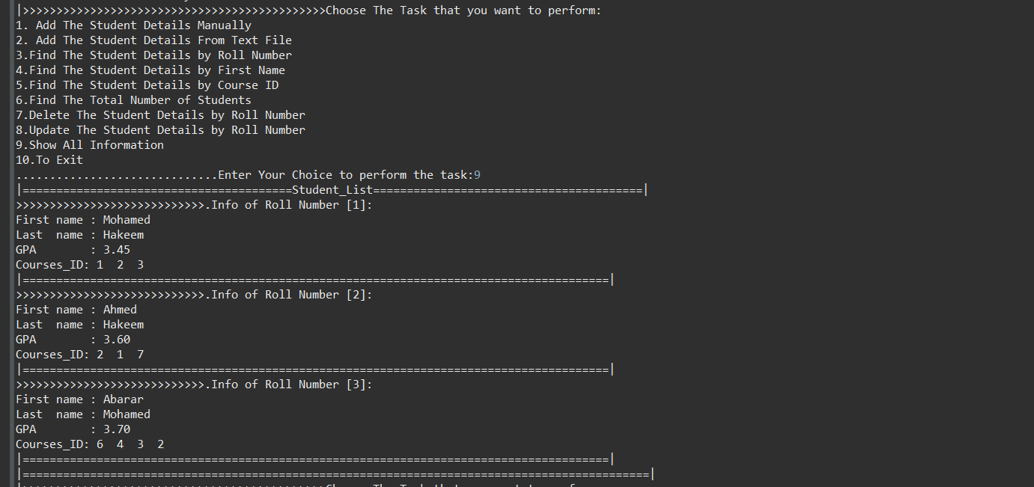

# Find By Roll Name

# Show All Information

# Find By Course Id

# Find By First Name

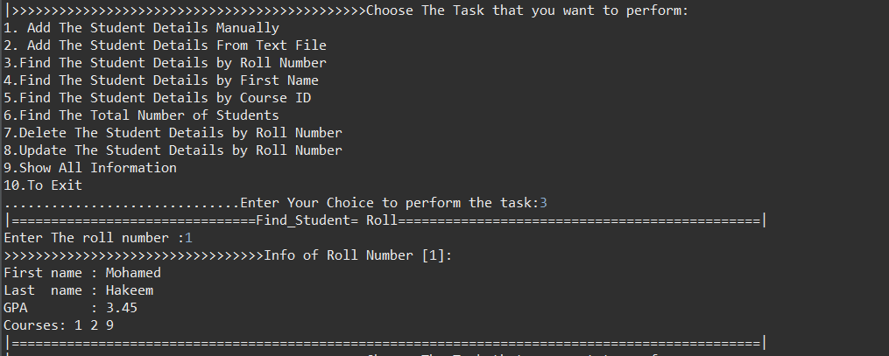

# Update Student data

# Total Number

# Delete Student

# Add from File

